**Software Requirements**

**Specification**

**Polygon**

**Version 1.0**

**Prepared by A. SAI SUDHEER REDDY (U101114FCS199)**

**Polygon networks**

**13.09.2016**

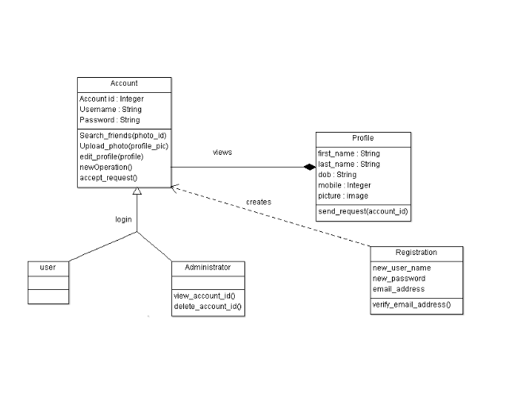

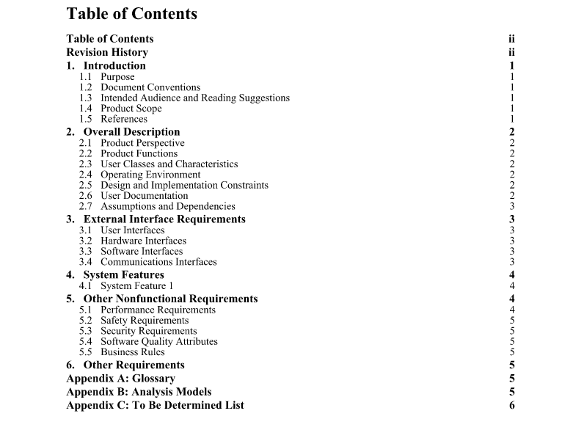

**Revision History**

|  |  |  |  |
| --- | --- | --- | --- |
| **Name** | **Date** | **Reason For Changes** | **Version** |
|  |  |  |  |
|  |  |  |  |
|  |  |  |  |

**1. Introduction**

**1.1 Purpose**

This mobile application was created to overcome the communication barriers in colleges in innovative way. This mobile application (Polygon 1.0 version) will be available to all the students (currently only for NIIT University). Polygon also has a huge scope being one of the most innovative social networking service of all time. The irregular geometric shape polygon with all diagonals connected represents the people in different countries across the globe connected to each other with our network.

**1.2 Document Conventions**

Calibri (Body)- standard type style used for most text, Calibri (Body) bold – used for headings and for index. The document doesn’t contain any special symbols. Every requirement statement in the document has its own priority.

**1.3 Intended Audience and Reading Suggestions**

The following document is planned for documentation writers. Rest of the document contains details about the concept and software and user interface along with the design and implementation constraints. The document should be read from the beginning, mentioned above are much more important to understand the complete picture .Tounderstand the UI can begin with the 3rd chapter and 4th chapter to know the system features.

**1.4 Product Scope**

By taking a picture of one click, you will get the information and you could know about this person that he provided by using Polygon application. Our aim is to let students of same interests in a college could know each other and make them work together which make people productive and even helpful. Our app also has scope of being used as an automatic student attendance system, the person using this app can join other students in the colleges, our corporate goal is to reach to all the colleges across the country and to be in the hands of every student.

**1.5 References**

The SRS document has been prepared by taking IEEE830 document as a reference and the use case diagram has been prepared by referring to the standard social networking use case diagram. Reference link: http://image.slidesharecdn.com/random-140623014539- phpapp01/95/social-networking-site- 23-638.jpg?cb=1403487994

**2. Overall Description**

**2.1 Product Perspective**

Polygon was created for students and educational organizations, the origin of the software took place when the opportunity in this area was identified. The app requires a third party application face-plus- plus support for face recognition algorithm and database support.

**2.2 Product Functions**

User should be able to send photo requests to the server and if the request is accepted they are to be able to receive their information.

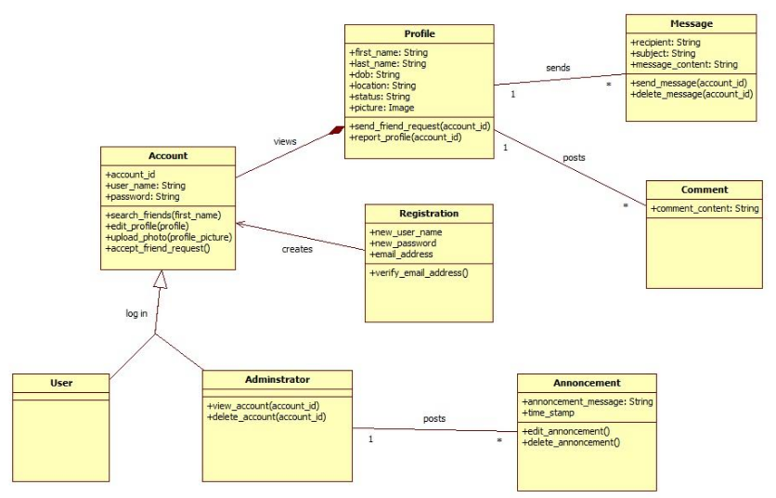

**2.3 User Classes and Characteristics**

Other classes includes the support we acquire from other third party software which we use for our face recognition algorithm. Those classes receive the photo and send us back the values which we store in our database. This class relation is currently not shown in the above diagram. The most important class in the system is account class which holds details all the details about the user.

**2.4 Operating Environment**

The application works in android smart phones and tablets with operating system above 4.2.2(Android Jelly Bean) which includes hardware requirements of front and rear cameras. These are the required specifications for the software to run peacefully stored.

**2.5 Design and Implementation Constraints**

For example if we take limited to 1500-2000 students and the available hardware couldn’t handle bandwidth above 100GB. Face-plus- plus also provides limited amount of bandwidth which is not enough for multiple queries. The polygon networks’ organization is responsible for maintaining the delivered software.

**2.6 User Documentation**

The app uses very simple and user friendly app, which can help people who don’t know how to use app. All the required terms and conditions are mentioned while downloading the app which will available in Android app store. We don’t find any need in preparing user manual for Polygon.

**2.7 Assumptions and Dependencies**

We assumed that there will be no hackers attack over the database until it upgrades to Azure cloud service. There are very few assumed factors in the SRS document. If that happens the information in the database will be lost. To avoid this kind of factor we must upgrade before we reach huge audience. The operational cost would increase and also the security issues will be raised if the assumption goes wrong. Polygon uses another web application which is documented and it can be used freely for non-commercial use, as long as polygon is growing it will be a non-commercial application.

**3. External Interface Requirements**

**3.1 User Interfaces**

The app contains login page at first to allow registered users to login to their wall. Login page also directs new users to signup page to create a new account, they need to upload their selfie and also needs to fill in the required data. The user activity area that comes after login allows the user to take photo or change or update their information.

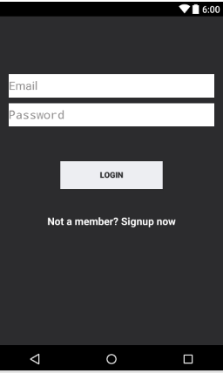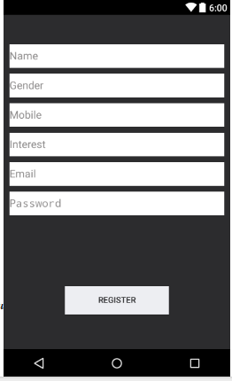

**3.2 Hardware Interfaces** The application uses database which stores the information regarding the user’s information. If any new user cell is created the database fetches information from face-plus-plus site and stores it. If any request made from other user matches the values of face of other user the details will be returned. The application is currently supported for android OS above 4.2.2 (Android Jelly Bean).The device requires dual cam front and rear and internet connection

**3.3 Software Interfaces**

We are using face-plus-plus 1:1 face verification method to detect the face and also to store required face values. Polygon 1.0 also uses 000webhost.com database to store the user’s information. The photo of user is sent to face-plus-plus and the returned values are stored in our database. App currently works in android smart phones with operating system on or above version 4.2.2. Face-plus-plus provides free API support for non-commercial use and 000webhost also provides free database service until we reach 100GB storage. All the data is shared with 000webhost and all the photo requests are shared with face-plus-plus site.

**3.4 Communications Interfaces**

The application requires communication to other servers and databases this includes web browser and also network server communication. Software uses hypertext transfer protocol and it also uses UTF 8 encoding and the database is also an encrypted database. We have 100GB bandwidth which can handle the current population.

**4. System Features**

This app will be very useful for people who wants to know details of an unknown person in his area, he just needs to take his photo the other person also gets details about the first person. This will create a mode of communication between them. Account user class contains searching and uploading of photos, is also contains the edit option. Account class comes at the top of the hierarchy level as no other class can be reached without this. Profile class contains details of the user and they can also request for someone’s details in this class.

**4.1 System Feature 1**

4.1.1 Description and Priority

Polygon application is feature-rich software which has too many features to serve its purpose. Above all the feature of sending notification that you have been photographed is the most important feature. It has the highest priority of 9 and other features include asking permission whether to share the details or not this can be rated at 5 medium priority. All of these facilities may cost a little but these will be a huge benefit in terms of security.

4.1.2 Stimulus/Response Sequences

The user when photographed by some person will get a notification about details who clicked the photo and when, he will also be shown the taken photo. If he/she wish to share their details their personal data will be shown.

4.1.3 Functional Requirements

REQ-1: user data storage

REQ-2: Photo request

REQ-3: notification request

REQ-4: Same interest person in locality request

|  |  |  |  |  |
| --- | --- | --- | --- | --- |
| Requirement identifier | Req 1 | Req 2 | Req 3 | Req 4 |
| 1.0.0 | X |  |  |  |
| 1.0.1 |  | X |  |  |
| 1.0.2 |  |  | X |  |
| 1.0.3 |  |  |  | X |

**5. Other Nonfunctional Requirements**

**5.1 Performance Requirements**

The database fetches information from face-plus- plus site and starts its search in the database, if a person requests for query. as long as the database is small the search algorithm finds the required data and returns the values, but if the database grows big enough it will take a lot of time which is not much reliable. So instead of standard search technique binary search or any better techniques has to be followed. The system is a real time system as the query is made real time and so the system should be more specific and more efficient. At present the database is built using MySQL.

**5.2 Safety Requirements**

The database has to be more secured and for that after reaching 200 registrations the database will be changed to Microsoft’s azure and it will back up all the existing data in two servers. By doing so we will be able to keep the data safe even if the server crashes. The database is highly secured and any actions that are against the terms will be terminated and necessary actions will be taken.

**5.3 Security Requirements**

The application has few security issues regarding stealing of information of other people which have been taken into account and prepared the software keeping every aspect in mind. Everyone who uses this app requires authentication and should agree to the terms of usage. Only issue is taking pictures of others without their permission, we have had a solution for this problem, every user can keep all their information private and if someone takes their photo a notification will be sent to that person that you have been photographed and details of the person who took will be also sent-plus site.

**5.4 Software Quality Attributes**

This software is a next generation concept which needs some time for adaptation, it will be available for all the students and staff in NIIT University by end of November. The finished version of Polygon will be more accurate and more reliable. It will be very easy to learn this software. The software will be robust and also portable in the sense that you can use it from any of your device with same account.

**5.5 Business Rules**

All the members in the operational team are required to look after the correctness of the data that is being entered in the database and also observe the working of the servers. The managing team should look after the money that is required to keep the system running and also should create link with other colleges and organizations.

**6. Other Requirements**

Requirements of software includes few hardware requirements, database requires 1TB of storage memory and 100GB bandwidth to handle the current existing members, for internationalization we need database servers at every part of the world which can handle population around the covered area. Legal issues like taking photo of someone and storing it in your mobile is strictly prohibited and polygon doesn't store any pictures in your mobile, they will uploaded to the face-plus- plus server and even deleted from there.

Appendix A: Glossary

All the words included in the document are very clearly pre-defined and no such shortcuts are used.

**Appendix B: Analysis Models**

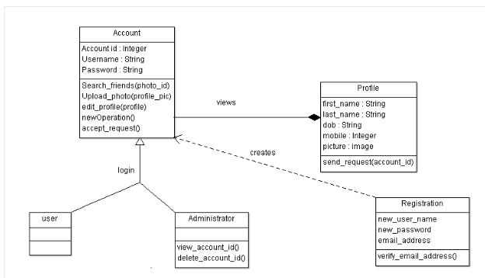

**Appendix C: To Be Determined List**

System features reference link: <https://en.wikipedia.org/wiki/Software_feature/> Third Party application for face recognition: <http://www.faceplusplus.com/>

Database hosting server: <https://www.000webhost.com/>